13.101: a) The spring, when stretched, provides an inward force; using 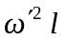 for the magnitude of the inward radial acceleration,
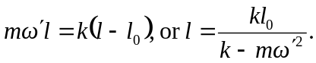

b) The spring will tend to become unboundedly long.

